 |  | Solution Design Document
 |  | ESP KPI Tracker
Business Owner/Dept: | Shane Wolf | Date Prepared: | Dec 20, 2022
Business Approver: | Travis Swallow | Prepared By: | Wayne Green
Revision History
Date | Version | Contributor(s) | Comments
Oct 11, 2022 | 1.0 | Wayne Green
Nov 10, 2022 | 1.1 | Wayne Green
Nov 24, 2022 | 1.2 | Wayne Green | Updated Context and Infrastructure Diagrams
Dec 20, 2022 | 1.3 | Wayne Green | Added Onboarding / Offboarding procedures.
Related Documents
File Name | Description
Business Requirements Document | Business Requirements Document
Cloud Questionnaire | Cloud Questionnaire
Logical Data Model | Logical Data Model
Context Diagram | Context Diagram
PWA Architecture | Progressive Web Application Architecture
Workflow Diagrams | Folder Containing all of the Workflow Diagrams
SOW | Statement of Work
Project Plan | Project Timeline and Effort Estimator
Table of Contents
Business Design 2
Application Solution Questionnaire 3
Architecture 3
Presentation Layer 5
Data Management 6
Security 7
Use Cases 7
Reporting 19
Service Delivery and Service Support 19
Reviewed by 19

Business Design

Design Rationale
Over the past four years, CNRL has spent more than $174 million on Electric Submersible Pump upgrades and replacements. The ESP committee has eliminated waste, enhanced runtime, and reduced costs, achieving some advantages; nevertheless, in order to reduce our total cost of ownership, CNRL must be able to predict impending failures utilizing the large quantity of performance and maintenance data we have acquired.

CNRL (Thermal and Conventional) now tracks ESP reliability, cost, root cause investigation, KPI reporting, and live pump performance in a sizable, unwieldy Excel file. There are more than 1,800 periods (installs, failures, and pulls) in the database that go all the way back to 1992. There is no straightforward method to consolidate post-mortem failure facts or lessons learned throughout the whole organization as this product is utilized by six separate districts. The methods for gathering data and applying quality control are constrained by Excel. The manual data entry process takes a long time, as does detecting problems and producing results.

Revised Business Process
Instead of CNRL employees entering information by hand, ESP providers would be able to send information through an external-facing progressive web application. This information would then be saved in an Oracle database. The system would notify the ESP users when new data has been input.

Subject matter experts could then concentrate on analysis rather than data administration thanks to a dedicated ESP tracker, which would also increase data quality and availability. Instead of responding to errors, there is more time for data analysis and preventive maintenance. A considerable decrease in the number of pump failures is the expected result.

Application Solution Questionnaire
Application Solution Questionnaire was completed and the results indicated a Cloud solution. The scoring was Cloud – 5 and On Premises – 10.
Cloud Survey

Architecture

Application Diagram

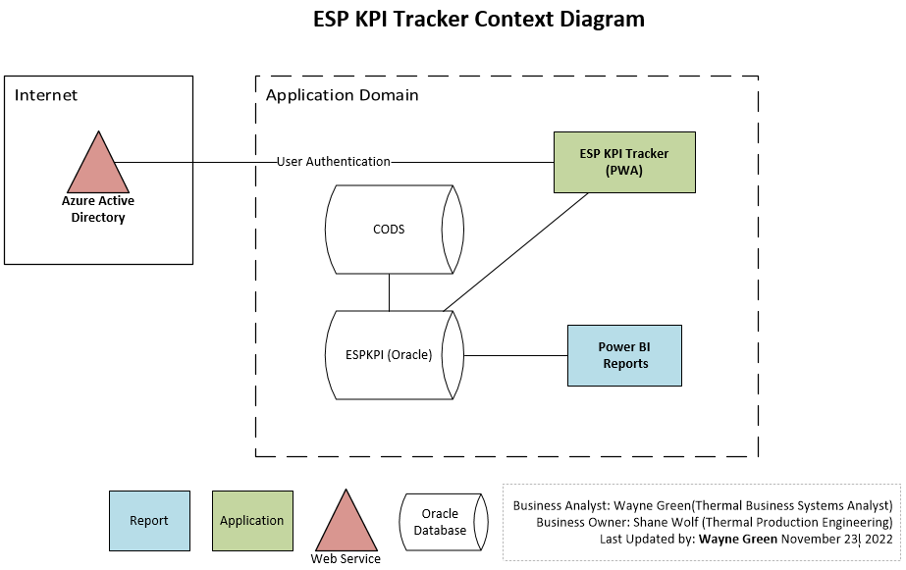

Infrastructure Diagram

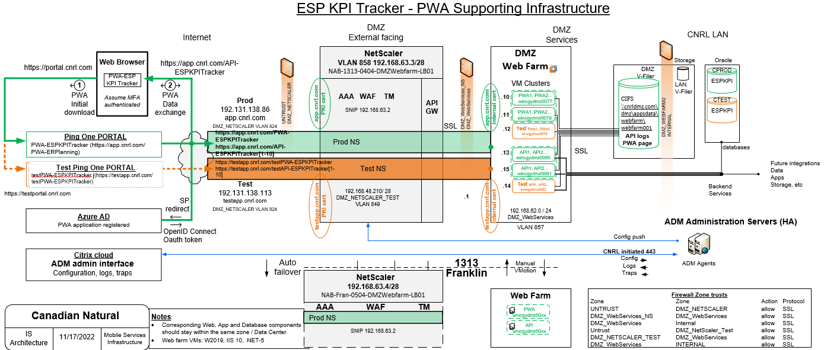

Presentation Layer
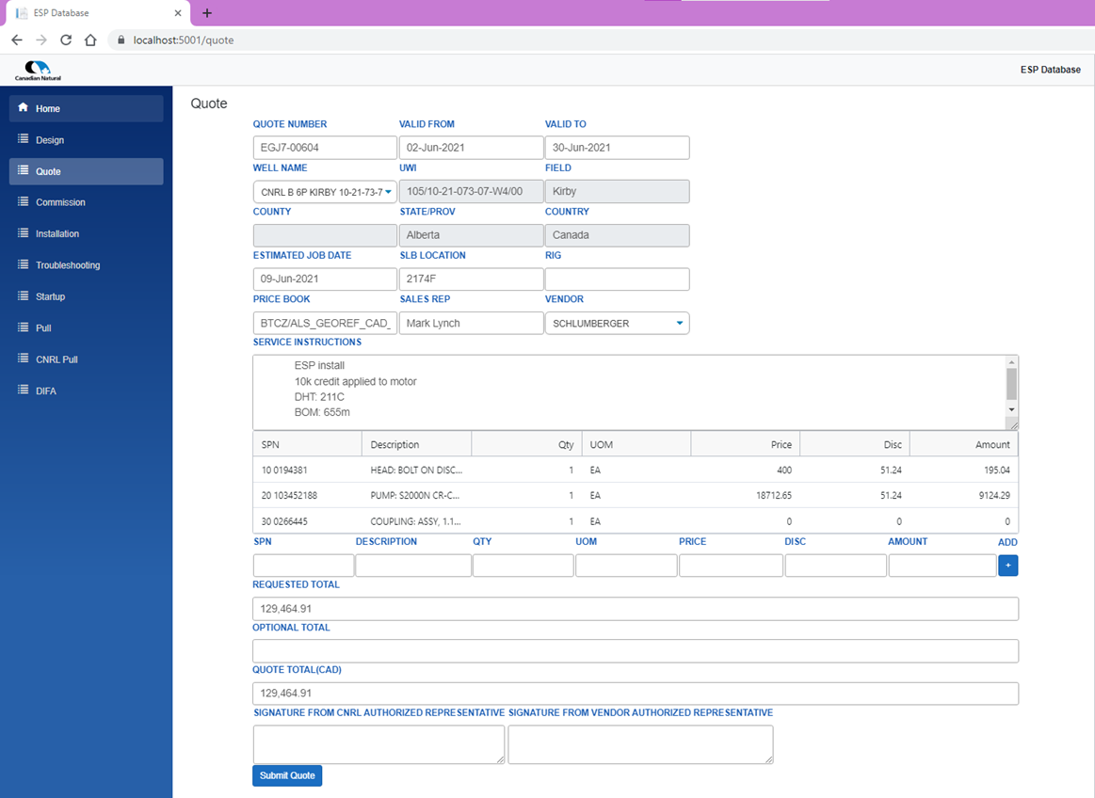

Data Management

Logical Data Model

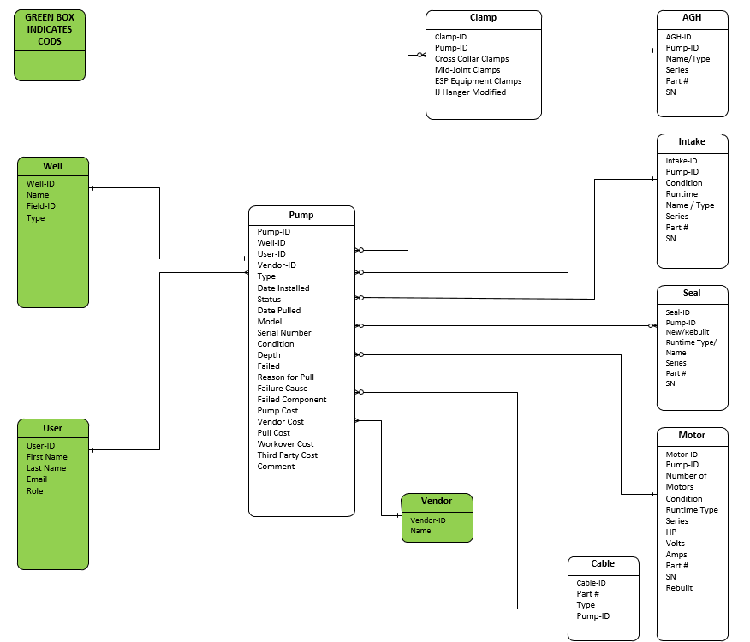

Security

Application

Security Roles
Role | Description
Viewer | Read only access.
SME | Complete access to all fields with the exception of User data, which is read-only. Reserved just for ESP Advisory Board members.
Vendor | Access to the external portal will be granted to authorized parties that supply pump data. Users with this function may generate and modify Quote, Install, Design, Commission, Start, Troubleshoot, and Pull data.
Administrator | Read / Write access to all fields.

Integration Requirements

In order to authenticate external and internal users, the ESP system needs to connect with PingID and Active Directory, respectively. Approximately 18 external users will need separate CNRL AD accounts in order to access the externally accessible PWA. It is anticipated that the accounts will need MFA to access the application interface. The user accounts will stay relatively steady since vendor turnover is limited.
Onboarding External Users
The vendor will be required to contact Shane Wolf and provide Name, Email and Phone number.
The BSA will be responsible to onboard each individual using the process defined below.
The vendor accounts will be reviewed every 6 months and inactive accounts will be removed.
To hire a new contractor, follow the steps below:

- Click http://myrequests.cnrl.com/ContractorApproval.aspx

- Select New Person

- Fill out the required fields and click submit. –> Contract type –> SLA NO HC (existing vendors) or MGSA for a new vendor.

  - If it is a new vendor, fill out all the requested fields and submit.

- Approvals will be automatically be routed to business approvers.

- After your request has been approved, follow steps 6-7.

- Go to your Profile –> Staff –> Provision New/Returning Person.

- Search for your Contractor by name. Populate the fields.

Offboarding External Users
When a Contractor leaves CNRL, you need to email ContingentWorkers@cnrl.com so that we may terminate them in the system. They will continue to have access to our systems until this is completed.
To view your active contractors, click the link below to access the CNRL Active Contractor List report.
Active Contractors
You will only see contractors to whom you have been allocated. However, you may export the report and send it through email to anybody who requires access to this information.

Architecture
Both CNRL employees and outside vendors will have access to this custom-built software. I.S. Operations' standard cybersecurity architecture for public-facing web applications serves as the foundation for the application's security, and it is backed by CNRL's approved cybersecurity design principles.

Use Cases

1.0 - Login
Goal | Login
Expected Result | The solution will use the User’s domain credentials to allow log in
User Role | Admin, Read and Write, Read Only
Pre-conditions | User has been granted access to the application
Post-conditions | None
Assumptions | User is an internal CNRL user
Business Rules/Constraints | None
Success Scenario | User is able to log in using their network credentials
Alternate Scenario | None
Failure Scenario | User is unable to log in
External Systems Providing Data | None
External Systems Receiving Data | None
Programmers Notes

2.0 Admin adds User
Goal
Expected Result | New User is defined in the system
User Role | Admin
Pre-conditions | None
Post-conditions | None
Assumptions | User has CNRL ID and mailbox
Business Rules/Constraints | None
Success Scenario | New User is set up in the system
Alternate Scenario | None
Failure Scenario | Error message
External Systems Providing Data | None
External Systems Receiving Data
Programmers Notes

3.0 SME adds Well
Goal
Expected Result | New Well is defined in the system
User Role | SME
Pre-conditions | None
Post-conditions | None
Assumptions | Well does not already exist
Business Rules/Constraints | Minimum number of required field are needed
Success Scenario | Well created in the system
Alternate Scenario | None
Failure Scenario | Error Message
External Systems Providing Data | None
External Systems Receiving Data | None
Programmers Notes

4.0 SME adds Pump
Goal
Expected Result | New Pump is defined in the system
User Role | SME
Pre-conditions | None
Post-conditions | None
Assumptions | Pump does not already exist
Business Rules/Constraints | Minimum number of required field are needed
Success Scenario | Pump created in the system
Alternate Scenario | None
Failure Scenario | Error Message
External Systems Providing Data | None
External Systems Receiving Data | None
Programmers Notes

5.0 SME adds Vendor
Goal
Expected Result | New company is defined in the system
User Role | SME
Pre-conditions | Each vendor will have a unique ID
Post-conditions | None
Assumptions | Vendor does not already exist
Business Rules/Constraints | Minimum number of required field are needed
Success Scenario | Vendor created in the system
Alternate Scenario | None
Failure Scenario | Error Message
External Systems Providing Data | None
External Systems Receiving Data | None
Programmers Notes

6.0 SME updates Pump
Goal
Expected Result | Pump details displayed in data viewer based on selection criteria
User Role | SME
Pre-conditions | None
Post-conditions | None
Assumptions | Pump already exists
Business Rules/Constraints | Drop down fields used set selection criteria
Success Scenario | Pump data displayed in viewer
Alternate Scenario | None
Failure Scenario | Error Message
External Systems Providing Data | None
External Systems Receiving Data | None
Programmers Notes

7.0 SME updates Well
Goal
Expected Result | Repair details displayed in data viewer based on selection criteria
User Role | SME
Pre-conditions | None
Post-conditions | None
Assumptions | Well already exists
Business Rules/Constraints | None
Success Scenario | Drop down fields used set selection criteria
Alternate Scenario | None
Failure Scenario | Error Message
External Systems Providing Data | None
External Systems Receiving Data | None
Programmers Notes

8.0 SME updates Vendor
Goal
Expected Result | Vendor details displayed in data viewer based on selection criteria
User Role | SME
Pre-conditions | None
Post-conditions | None
Assumptions | Vendor is already exists
Business Rules/Constraints | Drop down fields used set selection criteria
Success Scenario | Vendor data displayed in viewer
Alternate Scenario | None
Failure Scenario | Error Message
External Systems Providing Data | None
External Systems Receiving Data | None
Programmers Notes

9.0 Vendor submits Quote
Goal
Expected Result | New Quote added to database
User Role | Vendor
Pre-conditions | Well already exists
Post-conditions | Quote created and attached to well
Assumptions | Standard form used for data
Business Rules/Constraints | There will be required fields sufficient to link the Quote to a Well
Success Scenario | Submitted data is loaded into a new Quote record
Alternate Scenario | None
Failure Scenario | Email generated to SME / Admin detailing failure
External Systems Providing Data | Mail server
External Systems Receiving Data | None
Programmers Notes

10.0 Vendor submits Design
Goal
Expected Result | New Design added to database
User Role | Vendor
Pre-conditions | Well already exists
Post-conditions | Design created and attached to Well
Assumptions | Standard form used for data
Business Rules/Constraints | There will be required fields sufficient to link the Design to a Well
Success Scenario | Submitted data is loaded into a new Design record
Alternate Scenario | None
Failure Scenario | Email generated to SME / Admin detailing failure
External Systems Providing Data | Mail server
External Systems Receiving Data | None
Programmers Notes

11.0 Vendor submits Install
Goal
Expected Result | New Install added to database
User Role | Vendor
Pre-conditions | Well already exists
Post-conditions | Install created and attached to Well
Assumptions | Standard form used for data
Business Rules/Constraints | There will be required fields sufficient to link the Install to a Well
Success Scenario | Submitted data is loaded into a new Install record
Alternate Scenario | None
Failure Scenario | Email generated to SME / Admin detailing failure
External Systems Providing Data | Mail server
External Systems Receiving Data | None
Programmers Notes

12.0 SME submits Install
Goal
Expected Result | New Install added to database
User Role | SME
Pre-conditions | Well already exists
Post-conditions | Install created and attached to Well
Assumptions | Standard form used for data
Business Rules/Constraints | Drop down fields sufficient to link the Install to a Well
Success Scenario | Submitted data is loaded into a new Install record
Alternate Scenario | None
Failure Scenario | Email generated to SME / Admin detailing failure
External Systems Providing Data | Mail server
External Systems Receiving Data | None
Programmers Notes

13.0 Vendor submits Commission
Goal
Expected Result | New Commission added to database
User Role | Vendor
Pre-conditions | Pump already exists
Post-conditions | Commission created and attached to pump
Assumptions | Standard form used for data
Business Rules/Constraints | There will be required fields sufficient to link the Commission to a Pump
Success Scenario | Submitted data is loaded into a new Commission record
Alternate Scenario | None
Failure Scenario | Email generated to SME / Admin detailing failure
External Systems Providing Data | Mail server
External Systems Receiving Data | None
Programmers Notes

14.0 Vendor submits Start
Goal
Expected Result | New Start added to database
User Role | Vendor
Pre-conditions | Pump already exists
Post-conditions | Start created and attached to pump
Assumptions | Standard form used for data
Business Rules/Constraints | There will be required fields sufficient to link the Start to a Pump
Success Scenario | Submitted data is loaded into a new Start record
Alternate Scenario | None
Failure Scenario | Email generated to SME / Admin detailing failure
External Systems Providing Data | Mail server
External Systems Receiving Data | None
Programmers Notes

15.0 SME submits Start
Goal
Expected Result | New Start added to database
User Role | SME
Pre-conditions | Pump already exists
Post-conditions | Start created and attached to pump
Assumptions | Standard form used for data
Business Rules/Constraints | Drop down fields sufficient to link the Start to a Pump
Success Scenario | Submitted data is loaded into a new Start record
Alternate Scenario | None
Failure Scenario | Email generated to SME / Admin detailing failure
External Systems Providing Data | Mail server
External Systems Receiving Data | None
Programmers Notes

16.0 SME submits Commission
Goal
Expected Result | New Commission added to database
User Role | SME
Pre-conditions | Pump already exists
Post-conditions | Commission created and attached to pump
Assumptions | Standard form used for data
Business Rules/Constraints | Drop down fields sufficient to link the Commission to a Pump
Success Scenario | Submitted data is loaded into a new Commission record
Alternate Scenario | None
Failure Scenario | Email generated to SME / Admin detailing failure
External Systems Providing Data | Mail server
External Systems Receiving Data | None
Programmers Notes

17.0 Vendor submits Troubleshoot
Goal
Expected Result | New Troubleshoot added to database
User Role | Vendor
Pre-conditions | Pump already exists
Post-conditions | Troubleshoot created and attached to pump
Assumptions | Standard form used for data
Business Rules/Constraints | There will be required fields sufficient to link the Troubleshoot to a Pump
Success Scenario | Submitted data is loaded into a new Troubleshoot record
Alternate Scenario | None
Failure Scenario | Email generated to SME / Admin detailing failure
External Systems Providing Data | Mail server
External Systems Receiving Data | None
Programmers Notes

18.0 SME submits Troubleshoot
Goal
Expected Result | New Troubleshoot added to database
User Role | SME
Pre-conditions | Pump already exists
Post-conditions | Troubleshoot created and attached to pump
Assumptions | Standard form used for data
Business Rules/Constraints | Drop down fields sufficient to link the Troubleshoot to a Pump
Success Scenario | Submitted data is loaded into a new Troubleshoot record
Alternate Scenario | None
Failure Scenario | Email generated to SME / Admin detailing failure
External Systems Providing Data | Mail server
External Systems Receiving Data | None
Programmers Notes

19.0 Vendor submits Pull
Goal
Expected Result | New Pull added to database
User Role | Vendor
Pre-conditions | Pump already exists
Post-conditions | Pull created and attached to pump
Assumptions | Standard form used for data
Business Rules/Constraints | There will be required fields sufficient to link the Pull to a Pump
Success Scenario | Submitted data is loaded into a new Pull record
Alternate Scenario | None
Failure Scenario | Email generated to SME / Admin detailing failure
External Systems Providing Data | Mail server
External Systems Receiving Data | None
Programmers Notes

20.0 SME submits Pull
Goal
Expected Result | New Pull added to database
User Role | SME
Pre-conditions | Pump already exists
Post-conditions | Pull created and attached to pump
Assumptions | Standard form used for data
Business Rules/Constraints | Drop down fields sufficient to link the Pull to a Pump
Success Scenario | Submitted data is loaded into a new Pull record
Alternate Scenario | None
Failure Scenario | Email generated to SME / Admin detailing failure
External Systems Providing Data | Mail server
External Systems Receiving Data | None
Programmers Notes

21.0 Vendor submits DIFA
Goal
Expected Result | New DIFA added to database
User Role | Vendor
Pre-conditions | Pump already exists
Post-conditions | DIFA created and attached to pump
Assumptions | Standard form used for data
Business Rules/Constraints | There will be required fields sufficient to link the DIFA to a Pump
Success Scenario | Submitted data is loaded into a new DIFA record
Alternate Scenario | None
Failure Scenario | Email generated to SME / Admin detailing failure
External Systems Providing Data | Mail server
External Systems Receiving Data | None
Programmers Notes

22.0 SME submits DIFA
Goal
Expected Result | New DIFA added to database
User Role | SME
Pre-conditions | Pump already exists
Post-conditions | DIFA created and attached to pump
Assumptions | Standard form used for data
Business Rules/Constraints | Drop down fields sufficient to link the DIFA to a Pump
Success Scenario | Submitted data is loaded into a new DIFA record
Alternate Scenario | None
Failure Scenario | Email generated to SME / Admin detailing failure
External Systems Providing Data | Mail server
External Systems Receiving Data | None
Programmers Notes

Reporting
PowerBI reports will be developed for the ESP KPI Tracker.

Service Delivery and Service Support
Standard support with Best Efforts recovery are expected.

Reviewed by
Name | Role | Date
Kruti Bhatt | Application Architect | Nov 22 2022
Carson Harding | Security Architect | Nov 17 2022
Shaun Darrah | Solution Architect | Nov 17 2022
Alba Salazar | Data Analyst | Nov 23 2022

